Evolution of Design
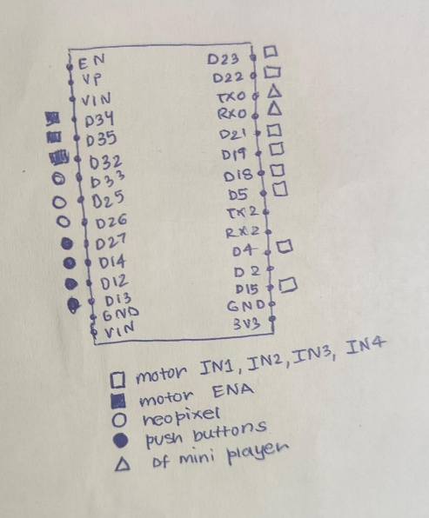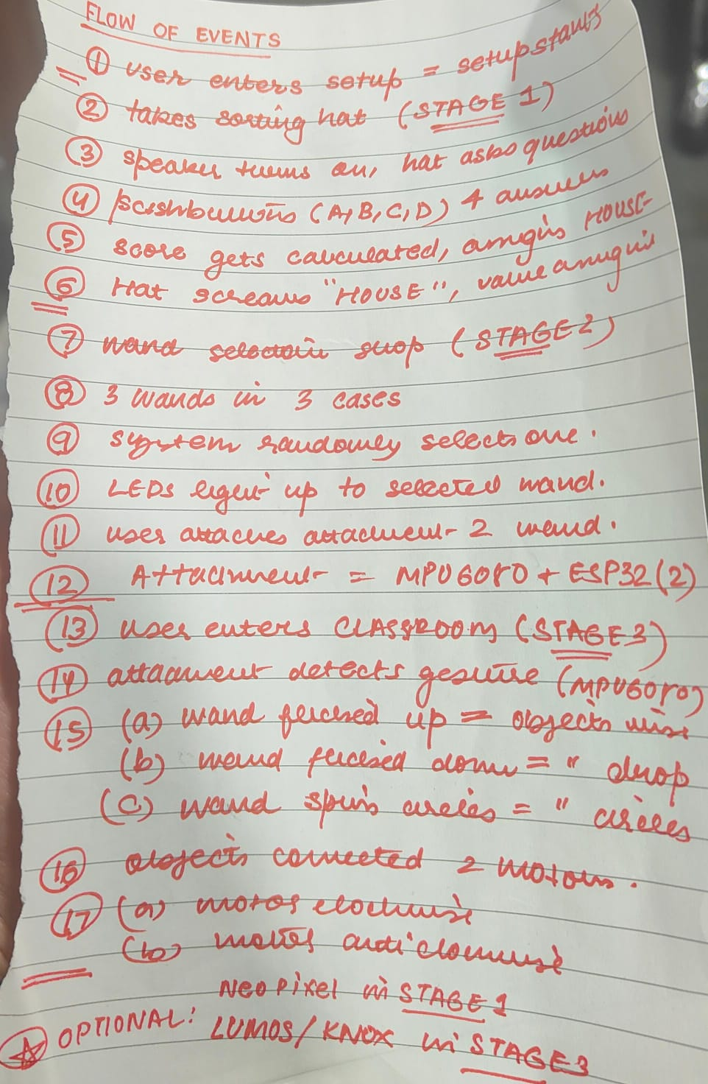
- Previous circuit diagrams that we had to update
- A flow of events list to define each step and stage
The flow of events list helped us keep track of each step and evolve things along the way. We had to adjust according to the project’s requirements. A few changes we had to make include:
We had to reprint the 3D wands as the first printer had some issues.
We had to create furniture using foam instead of sunboard to make it lightweight.
We kept running out of GPIO pins for our components -> fixing the circuit continuously.
Getting an MP3 Player with a built-in amplifier for the speaker - the hat’s voice & volume.
etc
Materials Chosen
Cardboard
Newspaper
Paper Mache
3D Printing
Glass Acrylic Sheets
Sunboards
Foam
Threads
Others: Paints, Spray Paint, Chart papers, Masking Tape (Structure), Glue, etc
Justification:
Cardboard: I cut out a ring of cardboard to make the base of the sorting hat. This made the hat sturdy so we could fit our components inside without the hat falling apart. It gave structural support to carry weight.
Newspaper: I then took newspaper sheets and made the conical shape of the hat. I used newspaper to make realistic looking folds and creases to mimic the real sorting hat. After making a sturdy paper mache layer on top of this conical shape, I again covered it with newspaper to make it easier to paint. These layers made the hat strong enough to withhold weight without collapsing at all. The face of the sorting hat was also made using newspaper as it is a material that can be easily manipulated.
Paper Mache: After making the base conical shape with newspaper, I made a paper mache mixture and pasted it on top. This made the hat absolutely rigid for support. We had to fit components and wires inside so this was an essential step to ensure the hat stays in one position, one place, without folding inwards/bending outwards.
3D Printing: Next, we 3D-printed models of the three wands. This was done digitally and at the labs. We wanted to 3D print them for a more professional look and also to create the perfect handle bar to fit our components inside – the second ESP32 and the MPU6050. This was an attachment made to fit inside the wands perfectly.
Glass Acrylic Sheets: I used glass acrylic sheets to construct three display boxes. These were identical in size and enhanced the overall look of the project. They were used as stands for the wands to light up and give a magical feeling. We felt this material would be perfect as the final display boxes should look clean, minimal, & transparent.
Sunboards: I used sunboards as the entire base of the classroom model and for most of the objects inside. It’s a sturdy material that can be easily carved and is great for structured, lightweight designs. The walls, floor (base), bookshelf, and table were all made using sunboard, and the books on the bookshelf as well.
Foam: To create the floating objects, it needed to be made with a material even lighter than sunboard. For this, I used foam to make the miniature chair and broom. The book was also made of foam so these objects could be easily lifted off the surface to give the illusion of a ‘floating classroom’. The feather and mail were made of paper to be even lighter than the foam objects for easier lifting.
Threads: I spray painted light blue threads with black paint to blend them well with the model, and look almost invisible. These was used to tie the ‘floating objects’ to the DC motors. It’s very lightweight and is perfect for the pulley system, since the DC motors cannot hold too much weight and needed to lift the objects effortlessly.

